The Island by Armin Greder
A unit of work developed by Laetitia Kilpatrick and Nigel Pearn

A book study supported by the use of process drama techniques to deepen student exploration and understanding of author’s purpose, character positioning and relationships and the moral themes of the story (developing critical literacy).
Text and activities appropriate for years 1-6

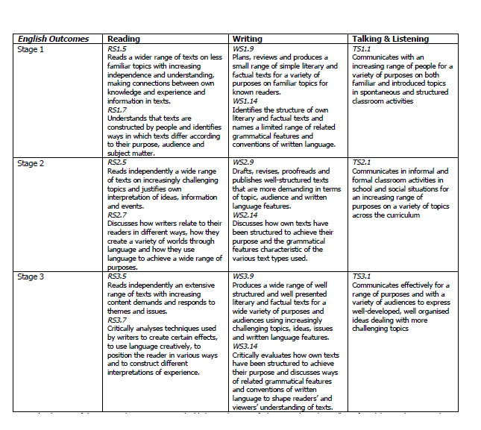
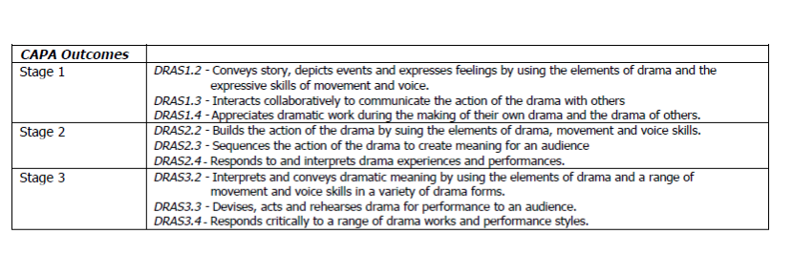

Learning Experiences in Sequence
Session 1 – Building the Field
- Using a large cardboard/paper cut out of an island on the floor, students are seated in a circle and draw or write what they think the topology, physicality or ideas about what an island might represent.
- Using SB page of class names in a table, class complete a discussion regarding what an island means or suggests to them- teacher records students ideas next to their names.
- Show image on internal title page of the text (dark waves with raft edge in foreground) on the smartboard. Ask students what they think the picture is of and what they see, question about the foreground if students do not offer this. Then ask students to find a space in the room in role on a raft. Teacher is in role and conveys the motion of the sea to change the experiences of the students in role and how they would ride a raft in a changing ocean. End activity with a storm and discuss what would happen to a person travelling on a raft in the event of this occurring.
- Bring class back together and read them the first page and reveal the man standing. Discuss why he might be different to the islanders – students do not know who or what the islanders are at this point so all ideas are valid and possible.
- Split class into pairs when one partner faces the smartboard and the other faces away. Reveal the ‘group of the islanders’ image on the smartboard and have those partners who are in view of the image describe it in detail to their partner. Then ask those listeners to feedback the words their partner used in the description prior to turning around to view it. Then have students turn around to see the group.
- Play version of red light/green light where class is the group and teacher is the man and creep up with appropriate body stance and facial gestures to convey power relationship between the two, take digital shots of these tableaus/frozen scenes

Session 2
- Start session by revisiting the images of the man and the group from the book in the notebook. Complete a Venn diagram about the similarities and differences between them.
- Continue reading “So they took him in”. Introduce visual literacy concept of salience at this point: size/colour/quantity and how this constructs the power and relationship between the characters in the text.
- Without revealing images or page to students read on “They took him to an uninhabited part of the island, to a goat pen that had stayed empty for a long time. They made him understand that he was to stay there and showed him where he could sleep on some straw”. Now reveal this text on a notebook page and ask the students to consider how the author’s choice of words can be interpreted to give the reader more information about the differences between the man and the group. Notably bold the section if students cannot identify it. Complete a cline around the severity of language/communication which positions this example around others suggested by students in the notebook.
- Teacher in role: teacher takes on the role of the man and asks a group of students how you could make him understand what they expected him to do. Afterwards discuss the difficulty of language barriers and the emotional means of communicating without voice.
- Complete session with reading of other text on that page “And then they…”

Session 3
- Commence session with recap of what the islanders did with the man and how life on the island returned to normal. Continue reading next page. Discuss salience of image of woman and introduce offer and demand (vis. Literacy). Consider why the illustrator has used a demand at this point in the text and the nature of this demand.
- Continue reading next page up until “…could they not give him something to eat”. Ask students how without the use of language he may have tried to communicate what he needed to the islanders. Using students in role, have them find a space and use other forms of communicating as the man.
- Read next paragraph up to “We must help him”. Have class form a conscience alley and teacher moves down alley asking for reasons/convincing of why they should or should not help the man.
- Teacher continues reading through to the end of the next double page spread.
- In notebook, have a range of dialogue from those pages of the text:
Grocer: “But we can’t just feed anyone who comes our way”
Innkeeper: “If he was in my kitchen, nobody would want to eat at my inn”
Carter: “Look at him! I need someone who can carry heavy loads”
Fisherman: “We took him in. We can’t turn our backs. Even though he is not one of us, he is still
our responsibility.”
As an exploration of reader’s theatre strategies, for each piece of dialogue highlight the words that should be emphasised to convey the emotional message/viewpoint behind the comment. Then discuss tone and volume of voice appropriate to each character. (Class can be split into small groups to compete this if desired). Perform lines of dialogue with emphasis, tone and volume. Discuss the difference between the rest of the men and the fisherman and why their tone should be/is different. (empathy)
- Continue reading and finish session with ‘And he eats bones!’

Session 4
- Start session by rereading the text across the bottom of the last two pages read commencing with ‘They hadn’t asked for him…” and continue onto the next two pages.
- Using the same reader’s theatre strategies as previous lesson, examine the dialogue on this double page spread and have small groups perform with emphasis, tone, pace and volume as related to the content of each excerpt.
- Continue reading up to “…seized the man”. Using sculpting and frozen moments have a student ‘sculptor’ sculpt a group of people and a man to reflect the image (most importantly to convey the salient parts) and the power within it. Use tapping in first of all for different characters in the scene to convey a sound or noise that would convey the commotion of the scene, then a single word and then a sentence, asking them to consider the tome/volume/ pace as before in previous activities.
- Complete session with reading and viewing of next page.
- Students then complete a writing activity (one of the following):
- write an alternative ending as to the fate of the man/ the island
- writing in role: a journal entry as the man at this point in the story
- letters from different islanders: fisherman/ teacher/ innkeeper

